**Lab - 20**

**Student Name: Navneet P**

**Student ID: AF0411619**

***Topic – Numpy Mathematical Functions***

Functions/Concept Used in the Assignment:

1. **Numpy Array Addition**: in python, using numpy you can simply add 2 different arrays using the + operator or the Numpy.add() function.
2. **Numpy Array Subtraction**: in python, using numpy you can simply subtrat 2 different arrays using the - operator or the Numpy.subtract() function.
3. **Numpy.multiply():** in python, using numpy you can simply multiply 2 different arrays using this function.
4. **Numpy.where():** This function is used to conditionally evaluate an array and store the result in a separate array. The result involves the indices of the elements which satisfy the condition.

Q1.  Calculate the total revenue generated by two product categories in a store

Input: category1_revenue = np.array([500, 600, 700, 550])

 category2_revenue = np.array([450, 700, 800, 600])

Solution: 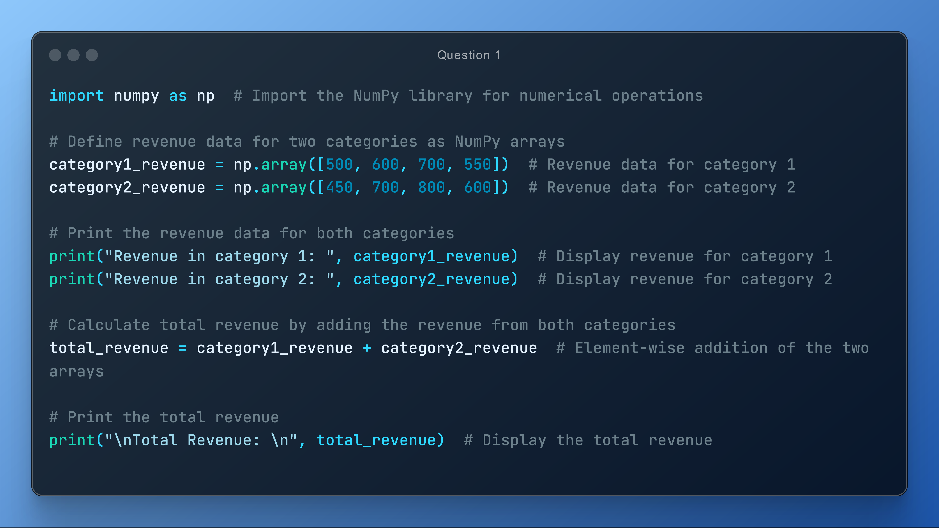

Output:

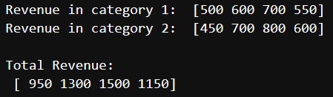

Q2. Calculate the profit made by a company

 Input: revenue = np.array([10000, 12000, 11000, 10500])

expenses = np.array([4000, 5000, 4500, 4800])

Solution:

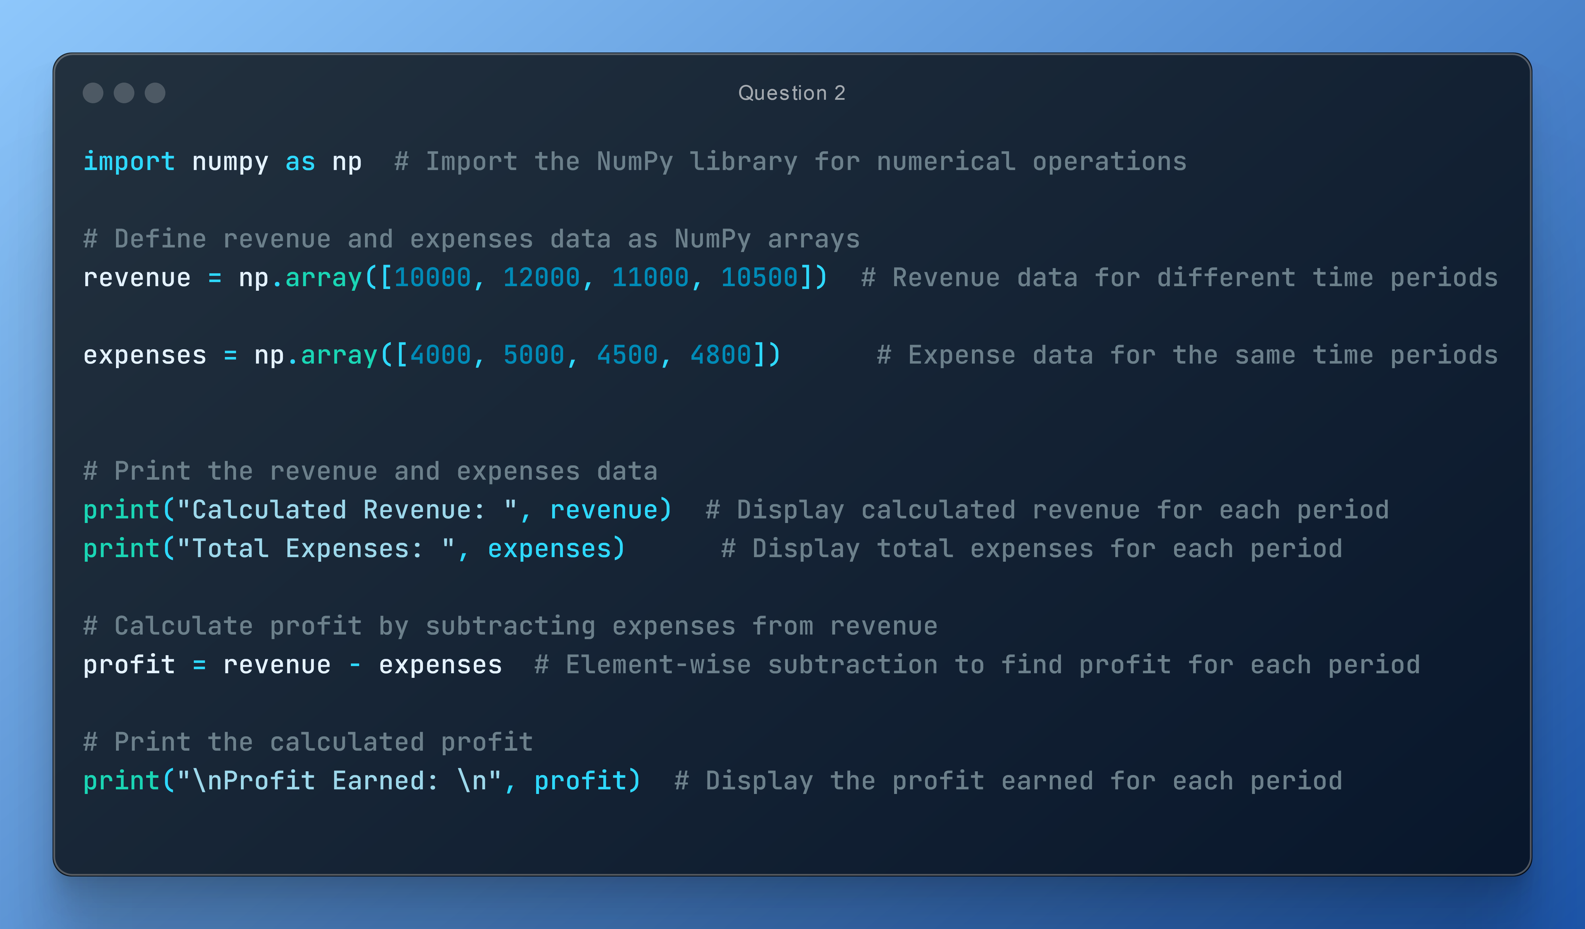

Output:

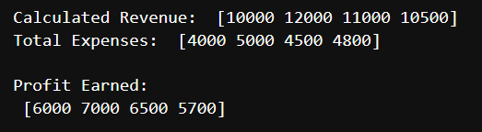

Q3. Determine which products in a store are out of stock (quantity is 0).

Input: inventory = np.array([10, 0, 5, 0, 20, 0])

Solution:

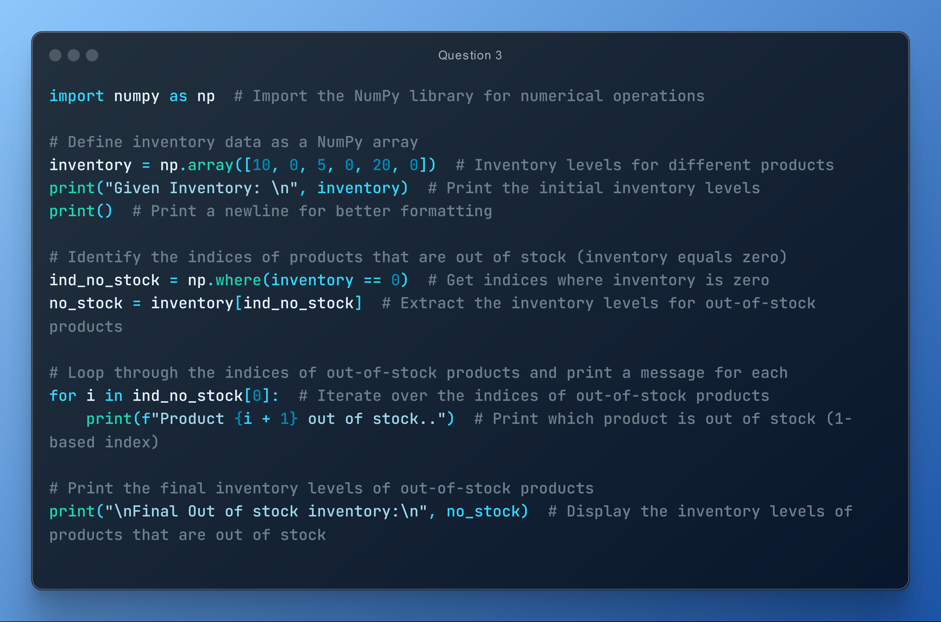

Output:

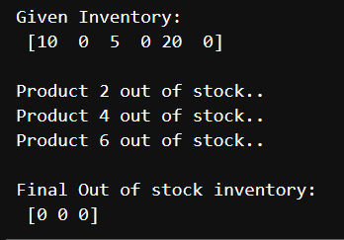

Q4. Calculate the total cost of items in a shopping cart, considering the quantity and price per item.

Input: quantity = np.array([2, 3, 4, 1])

  price_per_item = np.array([10.0, 5.0, 8.0, 12.0])

Solution:

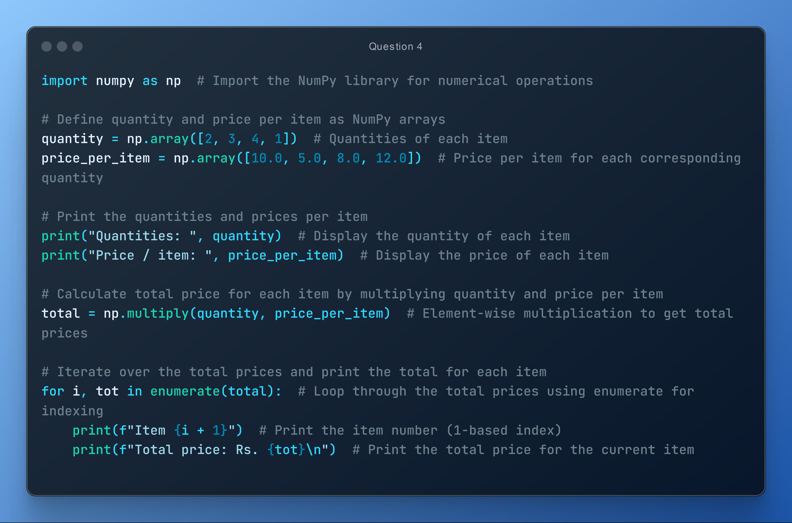

Output:

